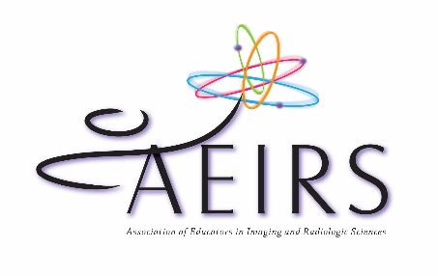
LEND A HELPING HAND
at the AEIRS Annual Meeting in 2022!

Name________________________________________

Email________________________________________

Room Moderator
Be in the room about 15 minutes before the first session starts in the morning (or afternoon) so that you can familiarize yourself with the room. Two moderators will monitor the doors to ensure we begin and end the sessions on time, one moderator will introduce the speaker and provide the CE information at the end of the lecture. Please indicate the day and session(s) for which you would like to be scheduled:
- July 7, 2022 AM
- July 7, 2022 PM
- July 8, 2022 AM
- July 8, 2022 PM

Assist with Business Session
Be in the hall where the luncheon will be served at 12:00 pm before the 12:30 pm luncheon starts. Place a business session packet on every chair.
- July 7, 2022 12:00 pm (requires missing a portion of the AEIRS Honors session)

Assist with Registration
Assist at the registration area to help prepare the area and help with registrations. Your assistance is needed during the times listed below. Please indicate all of the times for which you would like to be scheduled:

- July 6, 2022 4:00 pm – 6:00 pm
- July 7, 2022 6:30 am – 8:00 am
- July 8, 2022 6:30 am – 8:00 am

Assist with the Silent Auction
You can help set up the items, monitor the area, help collect bids, and get to know a lot of new people! Your assistance is needed during the times listed below. Please indicate all of the times for which you would like to be scheduled:
- July 8, 2022 7:00 am – 8:00 am (Set up Silent Auction)
- July 8, 2022 3:50 pm – 5:30 pm (Close Silent Auction and award auction items to highest bidders

Please return this form no later than May 30, 2022 to tammy.webster@unmc.edu

THANK YOU FOR VOLUNTEERING!

